Lab 8: Data Structures and Algorithms

**Topic: Doubly Linked Lists**

# Objective

* Working on the Doubly Linked List ADT
* Applications of Doubly Linked List

Note: We started Doubly Linked Lists paritally in the last lecture. No help will be provided during the implementation. Lab Instructors will help in using g++ compiler only.

## Task 1– To be done using g++ and Notepad (get away from Visual Studio for a moment)

Implement doubly circular linked list with the following functions:

1. Constructor
2. Insert at tail
3. Insert at head
4. Insert in sorted order
5. Insert from file (see explanation below)
6. Delete a node (cater all the cases) – This part is optional for Section C, but compulsory for Section A. Next lecture of Section C will start from this function.
7. Display from tail
8. Display from head
9. Sort values placed in the list in ascending order
10. Sort values placed in the list in descending order
11. Destructor – delete all nodes in linked list and empty the list

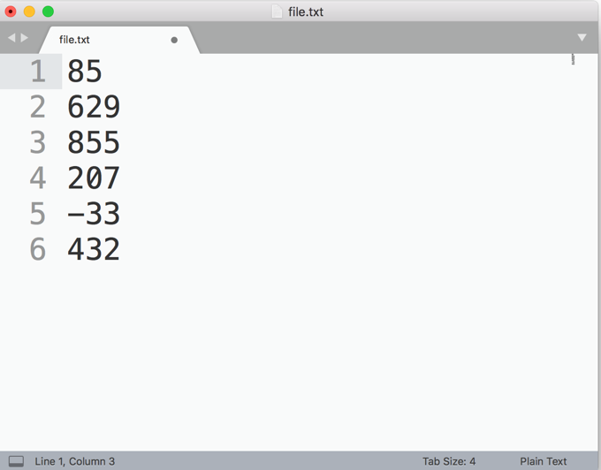

**Insert from file (explanation):**

Values will ALWAYS be placed in a file named “file.txt”. On each line, one value will be placed. You have to get the files from the file and create a new node against each file until the end of file is reached. Take an example of the file shown at the right side. As a result of selecting this file, a doubly linked list having 6 values will be created. Head will point at 85 and tail at 432. Rest of the values will be in between head and tail pointers.

## Task 2 – To be done using g++ and Notepad (get away from Visual Studio for a moment)

Repeat task 1, this time, using head pointer only.

## Task 3 – To be done using g++ and Notepad (get away from Visual Studio for a moment)

Repeat task 1, this time, using tail pointer only.

## Task 4 –

Create an online Library Book Issuance System in C++ to keep track of the issued book’s ISBN number, Book Name, Book Category (IT, Finance, Business), Student Reg ID, Student Name, Issuance Date, Return Deadline. Your program will use the doubly linked list implemented in Task 1. You can implement more than one doubly linked list. NO OTHER DATA STRUCTURE IS ALLOWED.

1. Determine whether your System is empty.
2. Determine the size of the System.
3. Destroy, or clear, the System.
4. Insert an item in the System after the specified name.
5. Insert data into System from a file (name of file must be **“data.txt”**)
6. Remove data from the Issuance System before the specified name.
7. Replace data against the specified ISBN number with another set of data.
8. Retrieve Book Name, Issuance Date, Return Deadline Date and Student Reg ID in the System from the kth location. (You are not allowed to use an array here)
9. Search and print the data for a given “Student Reg ID”.
10. Print all the books issued by one student either in ascending order.
11. Print all the books issued by one student either in descending order.
12. When the program terminates, write the data in the address book to a disk using filing.

Note: A menu-based application will show respective options.